A Basic Pulsar Detection System

Introduction
In a previous paper1 it was concluded that at least a 3m dish was required for detecting the strongest pulsars in both the North and South Hemispheres using the RTL2832U DTV dongle. Several amateurs have achieved this aim with 3m and larger parabolic dish antennas and efforts have been made to construct antennas more suitable for a small garden.
A. Dell’Immagine has been successful at 422MHz using a 3D corner reflector antenna with an aperture of 2mx2m to measure B0329+54.
S. Olney has successfully captured the Vela pulsar, B0833-45 in the southern hemisphere using a 5.7m long, circularly polarised 42-element crossed-dipole Yagi antenna at 436MHz.
In this note a pair of 2.5m long, 17-element Yagi antennas feeding three parallel RTL SDRs to cover the 608-611MHz radio astronomy band is described, together with methods to detect the B0329+54 pulsar at relatively low signal-to-noise ratios.

System Description
The frequency band 608-611MHz was chosen as a compromise between antenna size and being in a region of stronger pulsar signal levels than at the previous 1420MHz band. The hardware largely follows the outline given in reference at footnote 1, except for the simplification of the noise modulation switch. A noise source is no longer required (see Figure 1) as the synchronising function has been shown to be effective by switching the receiver system noise.

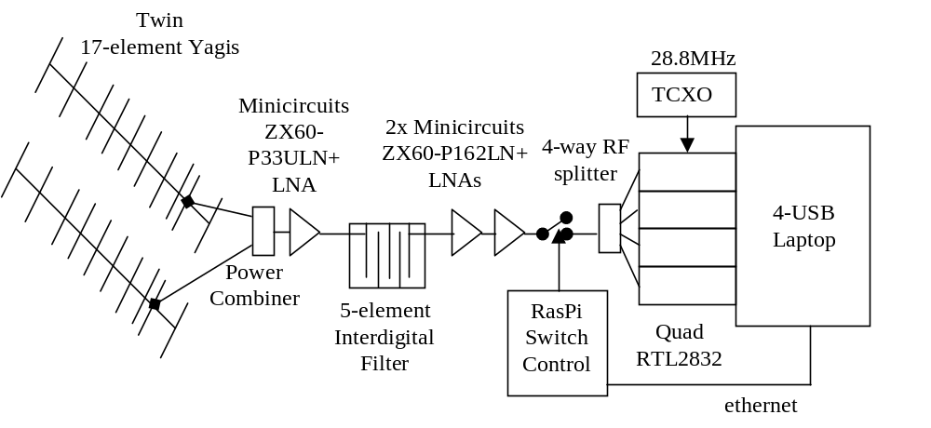

Figure 1 Pulsar Radio Telescope Schematic

The antenna developed for pulsar detection in the 611MHz radio astronomy band is a twin 2.5m long, 17-element Yagi. The design used the Paul McMahon design tool at the link: http://www.yagicad.com/yagicad/YagiCAD.htm, the resulting structure in aluminium is very portable.
The interdigital filter was designed using the tool by Ajarn Changpuak at link: http://www.changpuak.ch/electronics/interdigital_bandpass_filter_designer.php
This tool is particularly useful as it allows choices of box sizes, for instance the sides in this design were chosen as 25mm x 6mm for convenience of purchase and ease of manufacture; the box and 6mm copper rods are assembled simply using self-tapping screws (see Figure 2).

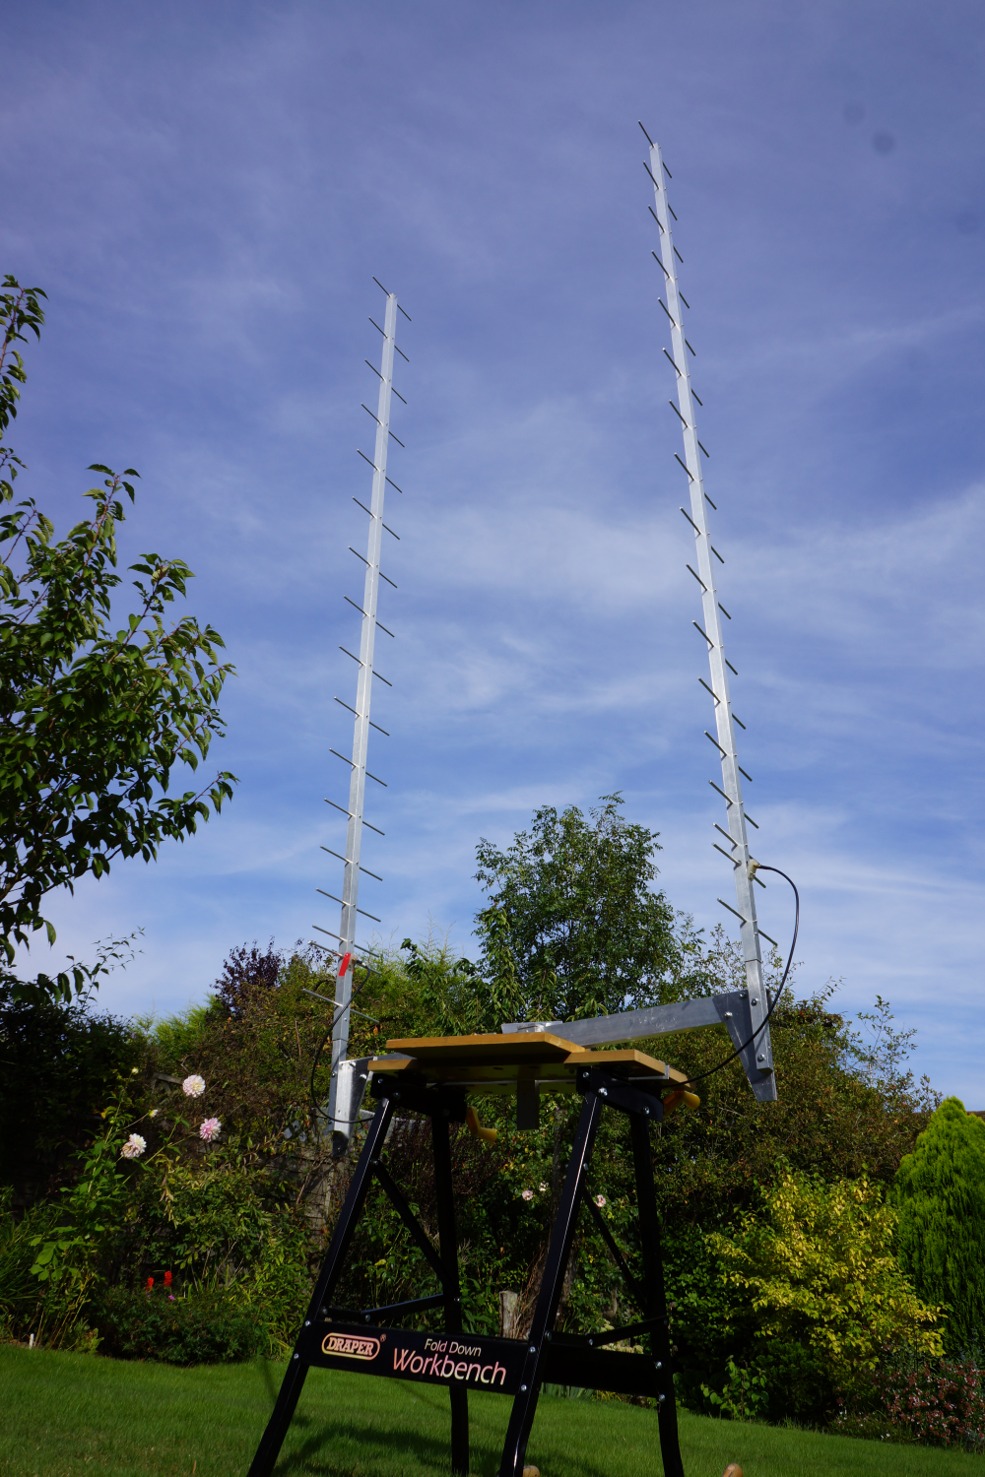

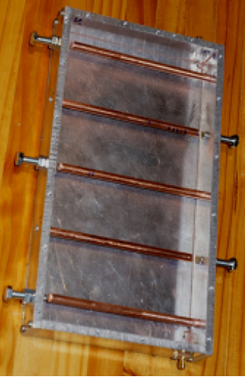

Figure 2 Antenna and Interdigital Filter Detail

Antenna: Two 17-element Yagi antennas with a theoretical combined gain of 19.3dB and electrical cross-section of 1.8m², mounted on a 1m aluminium frame with a combined design beamwidth of 28° x 14°. They can be oriented for vertical or horizontal polarisation. For portability and convenience, they can be mounted and steered on a modified builders workbench. 2-way power combiner loss <0.5dB.
RF Chain: One Minicircuits ZX60-P33ULN LNA (0.4dB NF, 28°) + 5-element interdigital filter + 2x Minicircuits ZX60 P162LN LNAs (0.6dB NF) + PIN diode RF switch + 4-way power divider.
Receiver: Quad RTL assembly driven by a single 0.5ppm TCXO and cooled with 4 fans.2 For the present tests, 3x RTLs are used at centre frequencies 609,611 and 613MHz and each run with a 2.4MHz clock. Gain setting is 33.6dB.
PCs: Dell Latitude D630 laptop with 4x USB ports running Linux.
RaspberryPi running Raspian, used solely for controlling the PIN modulating switch2 using its wired I/O ports.
Acquisition Software:
SSH terminal to control the RaspberryPi via Ethernet.
rtl_sdr22r modified Osmocom software to cope with producing large files and switching off the inbuilt dithering.
Processing Software:
pdetect22 - initial data checking and down-sample corrected files
cor_tim2_n – correlating modulation to enumerate offsets
filetrim – trim files to align data and include band dispersion correction
de-dispers2co – de-disperse data within bands
rapulsar2_avg2 – fold files
rfimit, pdetfilt2 for RF and/or video filtering if necessary. (use rafft22 and pafft22 to view RF /video spectra).

Validation Software:

DataCheck.mcd – simultaneous checking of file first/second half correlation, multiple period folding correlation, band correlation and period search optimisation. Period checked against daily topocentric value.

Final validation is effected by running DataCheck.mcd using unde-dispersed and over de-dispersed modified files.

Radiometer Equation and Sensitivity
The well-known radiometer equation is easily modified for the digital receiver case where data is ascribed to a fixed number of bins and becomes,
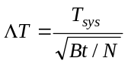

where, T_{sys} = T_{receiver} + T_{sky} + T_{antenna}
B is the RF Bandwidth and t, the observation time.
In the present case, B = 6MHz, t = 7500s and N = 109, so that 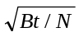 = 20,318
Using a practical result, after folding, the mean DC level of the folded plot is equivalent to T_{sys} and the rms noise level equivalent to ΔT. The measured ratio for Trial 24 was 22520.
This close agreement shows how effective the folding algorithm is in removing the effect of RF, video and spike interference. Although the observed interference level was low, some interference was clearly evident in the data.
In practice, software designed to remove interference prior to folding showed very little overall SNR improvement.
The folding algorithm, especially applied to very long records, becomes very finely tuned to the wanted period and will find strong peaks in random noise so that the pulsar validation routine must be very conclusive, especially when recovering low SNR pulsar signals.

Measuring Receiver Noise Temperature
Receiver noise temperature can be estimated by comparing the receiver output noise level with the LNA input open-circuited and loaded by a matched load since the expected noise power ratio is (T_{receiver}/(T_{receiver}+290).

Given T_{receiver}, then T_{antenna} can be estimated from the power received when the antenna is correctly directed.
Measurements using SDR# for the present receiver are; LNA input open-circuit =
-23.2dB; matched load = -16.0dB, antenna connected = -18.7dB. The software calibration is unknown, so these figures and those derived should only be taken as a rough indication.
From these figures,
T_{receiver} = 68°K, (and, including the power splitter, T_{matched}/T_{oc} -> 6.6dB so, T_{receiver} -> 81°K)

T_{receiver} + T_{sky} + T_{antenna} = 159°K, or T_{sky} + T_{antenna} = 78°.
These figures include the power combiner, but imply a strong contribution of antenna side and backlobes.

Results

Summary Table
Trial No. | 22 | 23 | 24 | 25 | 26 | 28
Date | 10/07/17  09.21 | 10/07/17  08.50 | 07/08/2017  07:30 | 24/08/2017 06:20 | 25/08/2017  06:19 | 27/08/2017  06:12
Data Recorded | 3x36GB | 3x36GB | 3x36GB | 3x36GB | 3x 36Gb | 3x36Gb
Best SNR | 4.42 | 3,86 | 3.56 | 3.50 | 2.84 | 3.439
Band SNR | 3.14,2.22,  2.42 | 3.36,1.24,  1.72 | 2.13,2.07,  1.64 | 1.96,2.91,  0.91 | 2.33, 1.06, 1.46 | 3.08,1.56,  1.33
Topocentric period | 714.4823335 | 714.4770104 | 714.467430 | 714.463891 | 714.463840 | 714.4637944
Topocentric period error | -0.375ppm | +0.125ppm | -0.375ppm | -0.75ppm | -0.5ppm | -0.25ppm
Noise ratio | 19780 | 22350 | 22520 | 24670 | 22020 | 22350
TCXO error ~-0.354ppm, maximum deviation over 6 records = 0.48ppm
Dates and times are UK local.

Trial No: 24 “First Light” Detailed Results
Trial No: 24, on 07/08/2017. Observation time 7500s around culmination at 86° elevation. Antenna elevation beamwidth 14° set at 84° elevation. Azimuth pointing direction set at 0°.
As an initial check; the measured detected dc to folded noise ratio is >20000 = (T_{sys} +T_{sky})/ΔT, indicating that ΔT is of the order 0.01°K. An SNR of 3 is therefore equivalent to a pulsar temperature of 0.03°K.
Assuming an effective antenna capture area of 1.8m², the Jansky peak equivalent is around 23J or 0.21J mean. (from T = JA/1380 ) This compares to the published data of 0.4J for a single polarisation.
In the plots following, the pulsar candidate is set at bin number 55 of 109 bins.
Topocentric period error for best SNR = -0.375ppm.
Figure 3 shows the result of folding all channel data, optimally moving the maximum to the centre bin and optimising the system clock offset. The SNR is calculated using all the data outside the bin maximum to determine the data mean and rms.

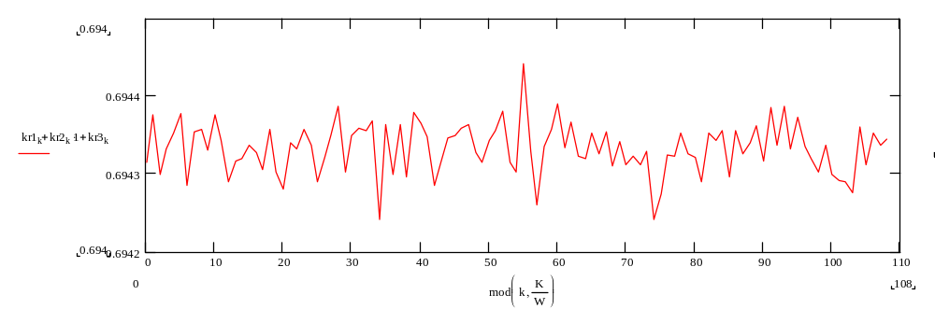
Figure 3 De-dispersed final result SNR = 3.556
(Band SNRs: 2.13, 2.07,1.64)

Figure 4 below plots the folded data response prior to the in-band data being de-dispersed. The channel data has been aligned to account for the dispersion between band centres.
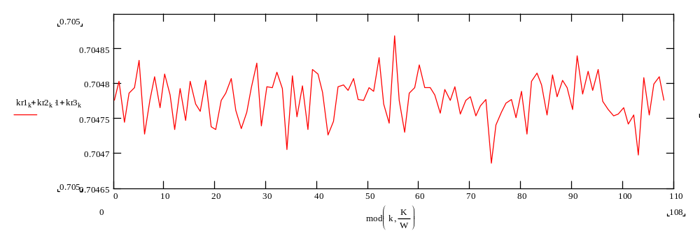
Figure 4 Band raw data result SNR = 3.096
(Band SNRs: 1.79 1.20 1.86)

Figure 5 plots the folded data response when the in-band data has been over de-dispersed by a factor of 10. A significant reduction in SNR and broadening at the central bin is evident, as may be expected. It is also evident that the bin responses of other bins has also been affected. Although non-pulsar wideband noise amplitude should not be affected by de-dispersion, the phases of components will be and this coupled with the non-flat band shape may account for the differences observed.

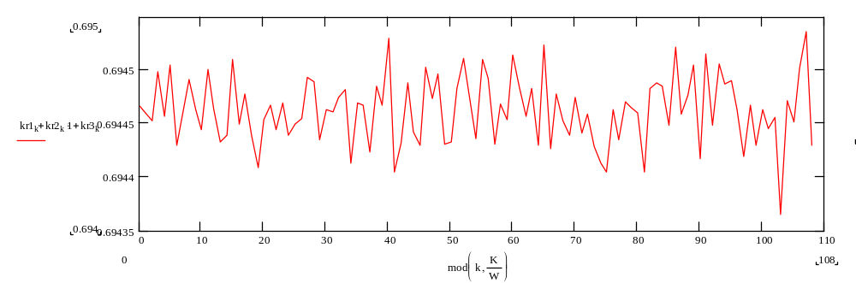
Figure 5 Band over dispersed (20ms) result SNR = 1.552
(Band SNRs 0.973, 0.862, 0.841)

Figure 6 plots the correlation between bands folded individually and shows a strong correlation of band responses at the expected bin.
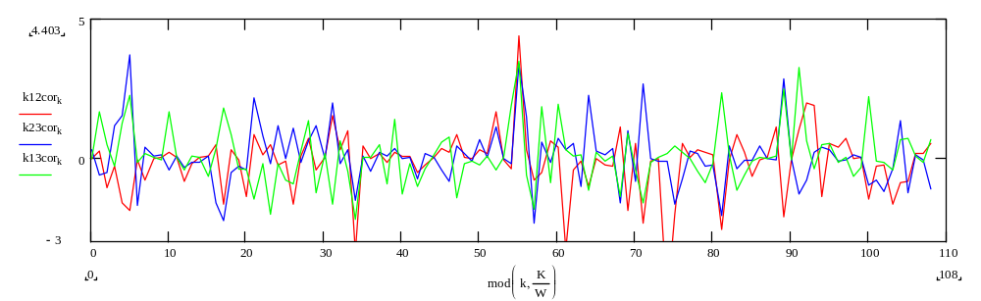
Figure 6 Band-to-band correlation
(red,1x2; blue, 2x3; green, 1x3)

Figure 7 plots the correlation between the two halves (first half red, second half, blue) of the combined data file, each folded separately, again showing strong correlation at the expected bin.
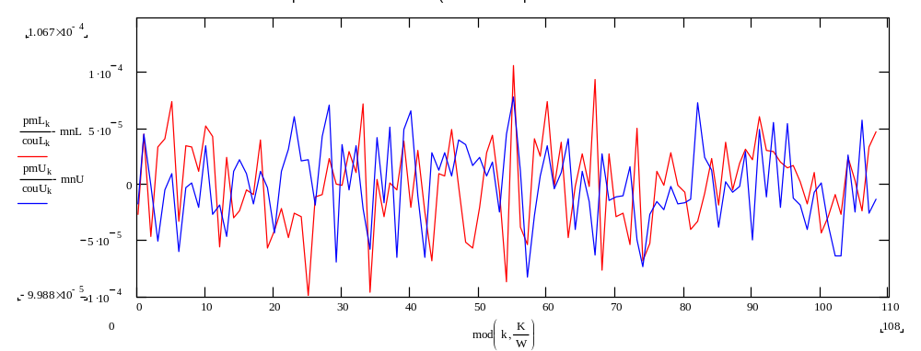
Figure 7. First half file v second half file correlation

Figure 8 shows the double period response of the two data file subsets, again showing strong correlation and pulsar pulse presence at the expected bin. For this presentation, the second pulse period has been overlaid on the first to prove pulse coincidence.
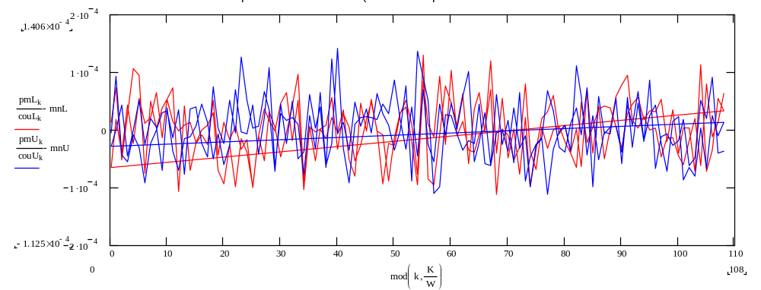
Figure 8. Double period correlation

Figure 9 optimises the folding period for best SNR is -0.375ppm
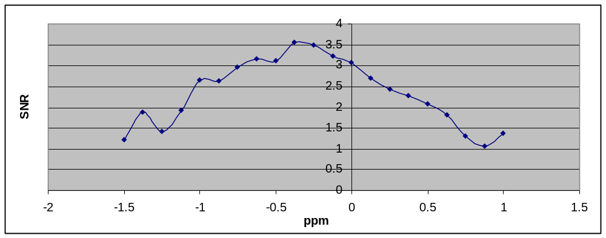
Figure 9. Pulsar Period Optimisation

Data Search Sequence
At these low SNRs, it is essential to take care to identify the wanted pulsar peak. There may be several likely candidates on first folding using the published topocentric period for the RT location. If MathCad is not available then the best procedure is to plot a two-period fold or a two half data file fold using 109 bins and shifting the data start in 1ms increments checking each candidate. Once a candidate has been chosen and set to the centre bin position a further check is to vary the fold period in increments of 0.125ppm.
A recommended search procedure is
• - Divide record in two and correlate sections
- Cross correlate multiple bands
- Shift data by one sample and correlate
- Try multi-period folds
- If these tests pass move candidate to centre bin and change bin number by 1 or more
- Check improvement with within band de-dispersion
- Check degradation with negative de-dispersion
- Check pulse width using high bin number folds
- Period search peak
A true pulsar will pass all validation tests and show day-to-day consistency.

Conclusions
It is shown that detection of the B0329 pulsar is possible using a basic receiving system based on a home-made Yagi pair antenna and TCXO-driven RTL2832U DVB dongles with relatively cheap RF LNA amplifiers. It is not easy to validate detections but with care and persistence it can be done. It is feasible to add daily folded data sets to improve overall signal-to-noise ratio.

Peter W East August 2017

1 Amateur Pulsar Detection
2 Quad RTL Receiver
2

